* **Personal Finance Tracker - User manual or README**

**Table of Contents**

1. **Introduction**
   1. Overview  
      1.2 Purpose of the Application  
      1.3 Target Audience
2. **System Requirements**

2.1 Hardware Requirements

1. **Getting Started**

3.1 Application Layout & Dashboard Overview

1. **Introduction**

***Overview***

The Personal Finance Tracker is a desktop-based Java application that helps users manage their personal finances in an organized, efficient, and secure manner. It offers a user-friendly interface to record daily income and expenses, categorize transactions, set monthly budgets, and define long-term financial goals.

***1.2 Purpose of the Application***

The **Personal Finance Tracker** is designed to assist users in managing their personal finances by providing a simple, intuitive, and secure platform to:

* **Record and monitor income and expenses**: Users can log every financial transaction, ensuring a detailed and accurate financial history.
* **Categorize spending**: Transactions can be grouped into common categories (e.g., Food, Transport, Utilities), enabling users to understand where their money is going.
* **Set and manage budgets**: Users can establish monthly spending limits for each category to avoid overspending and maintain financial discipline.
* **Define financial goals**: The application allows users to set personal financial goals such as saving targets or debt repayment milestones and track their progress over time.
* **Visualize financial data**: With built-in charting tools, users can view their spending and income patterns using pie charts and bar graphs, making complex data easy to interpret.

***1.3 Target Audience***

The **Personal Finance Tracker** is designed for individuals who seek a simple, offline solution to manage their personal finances. This includes:

* **Students** learning to budget their allowances and control spending.
* **Young professionals** managing salaries, expenses, and savings goals.
* **Freelancers and gig workers** who want to track irregular income and spending.
* **Budget-conscious individuals** who prefer to keep financial data private and offline.

Whether you're saving for a goal, cutting unnecessary expenses, or just trying to understand where your money goes, this tool is built for **everyday users** who value simplicity, control, and security in financial tracking.

1. **System Requirements**

*2.1* ***Hardware Requirements***

To run the **Personal Finance Tracker** smoothly, the following minimum and recommended hardware specifications are advised:

**Minimum Requirements:**

* **Processor:** Dual-Core 1.8 GHz or higher
* **RAM:** 2 GB
* **Storage:** 100 MB of free disk space
* **Display:** 1024×768 resolution
* **Input Devices:** Keyboard and mouse
* **Other:** Java-compatible system with GUI support

**Recommended Requirements:**

* **Processor:** Intel Core i3 or higher
* **RAM:** 4 GB or more
* **Storage:** 250 MB free space (for data growth and backups)
* **Display:** 1366×768 or higher resolution
* **Input Devices:** Keyboard, mouse/trackpad, optional touchscreen
* **Backup Device (Optional):** USB drive or external storage for database backups

1. **Getting Started**

**3.1 *Application Layout & Dashboard Overview***

The **Personal Finance Tracker** features a clean, user-friendly interface designed for easy navigation and efficient financial tracking. The main components of the layout include:

**Login:**

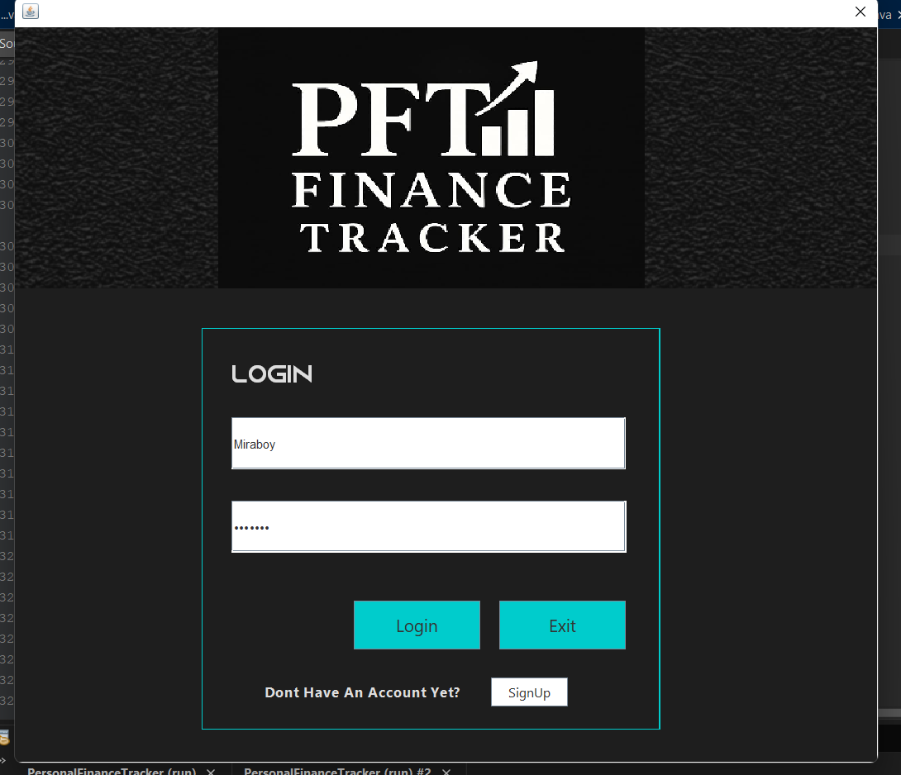

The **Personal Finance Tracker** may include an optional **Login** feature to protect user data and enhance privacy. If enabled, users must sign in before accessing their financial records.

**SignUp:**

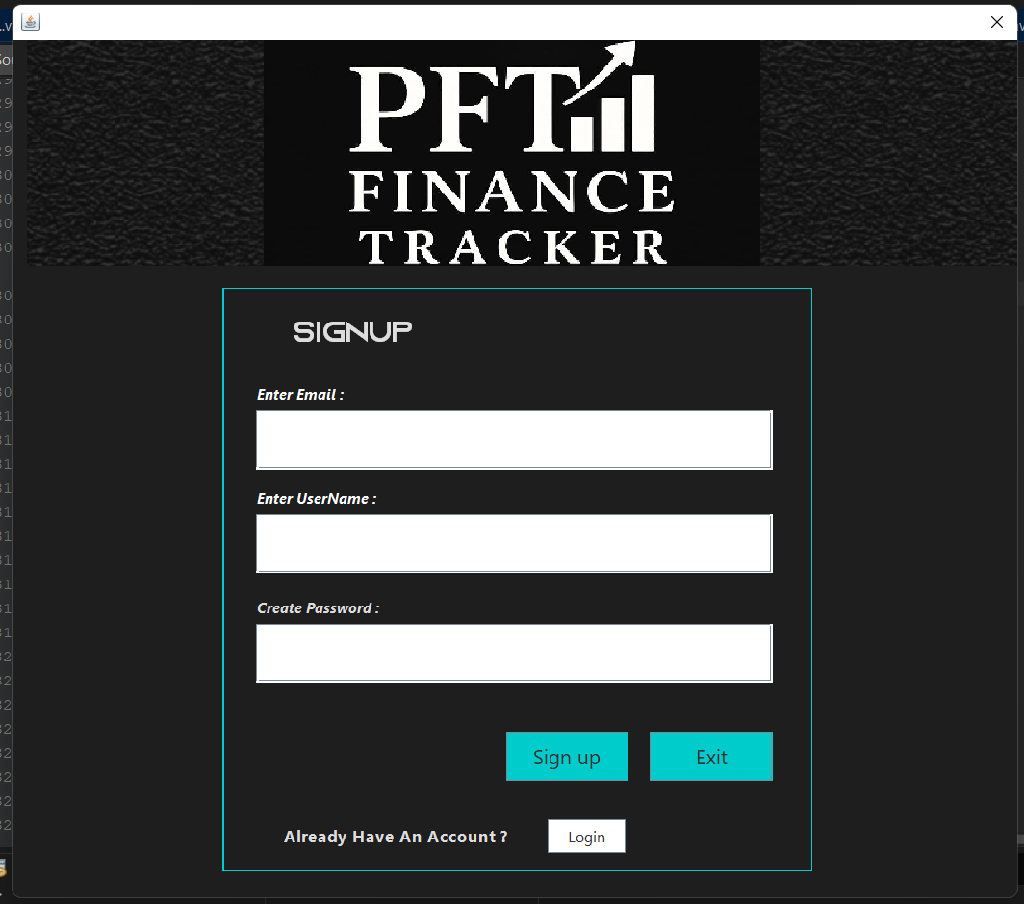

If the **Personal Finance Tracker** includes user authentication, new users must first **sign up** to create an account.

**Dashboard:**

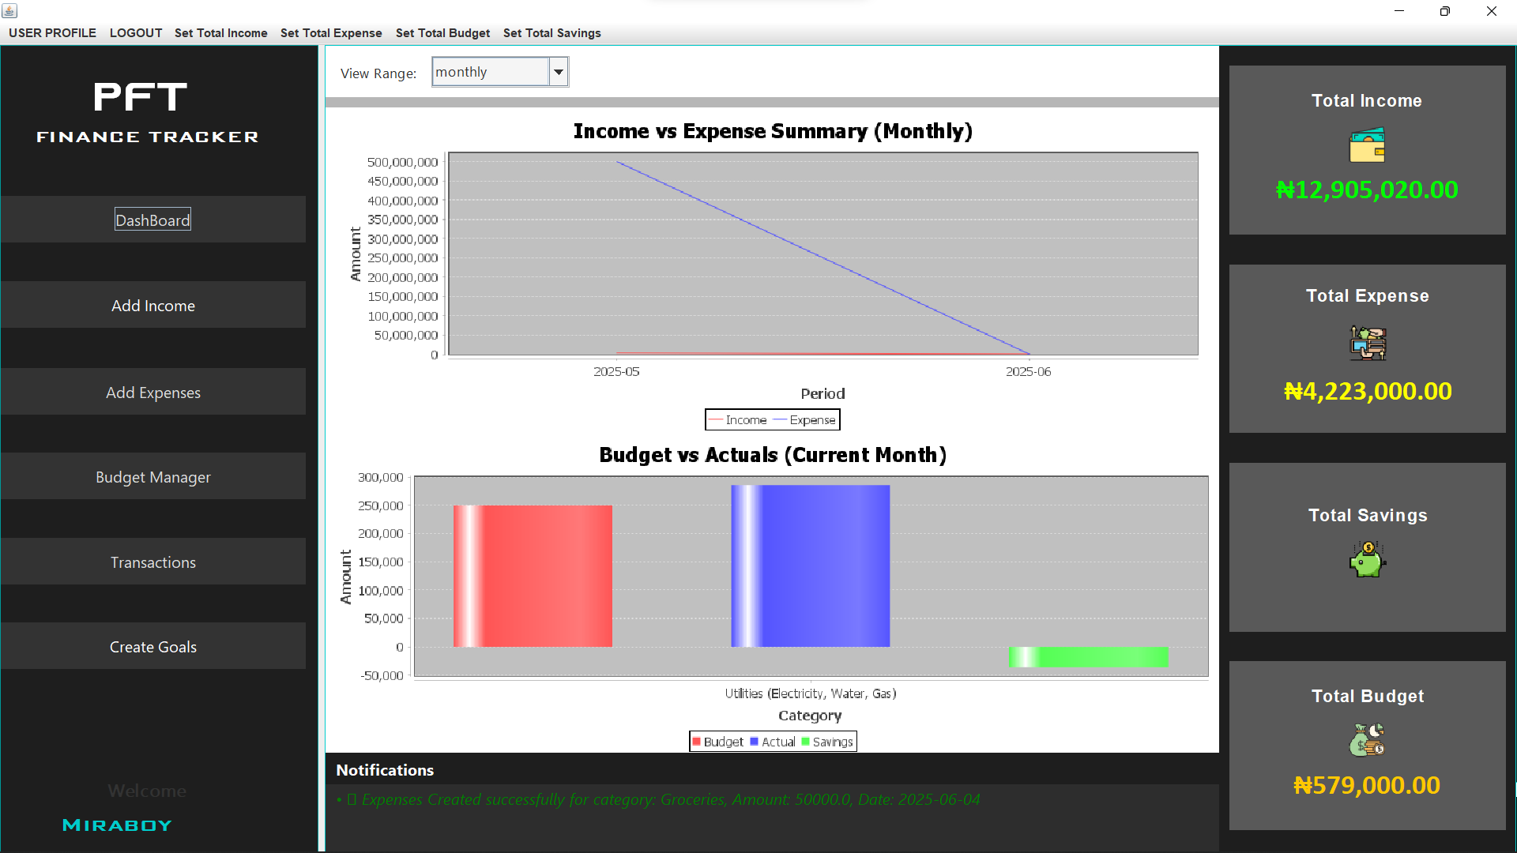

Provides an overview of your current financial status, including total income, expenses, balance, and recent activity.

**Add Income:**

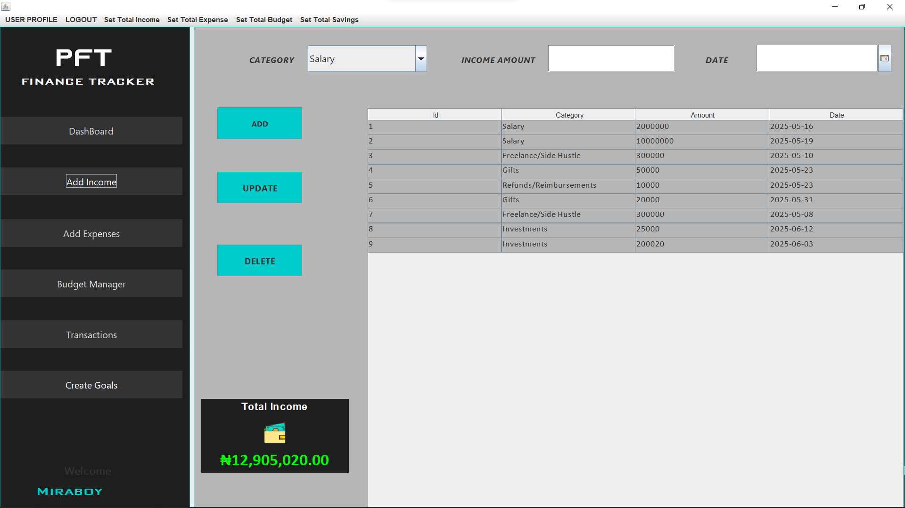

The **Income** feature allows users to record and track all sources of money they receive, ensuring a complete view of their financial inflows.

**Add Expenses:**

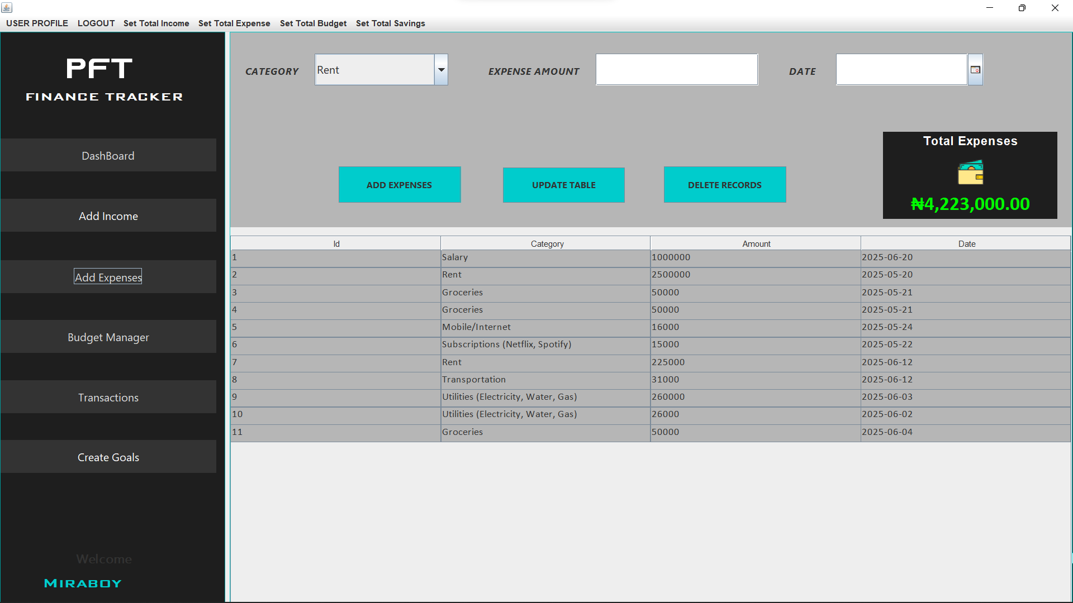

The **Expenses** feature lets you record your daily spending, helping you stay on top of where your money goes.

**Budget:**

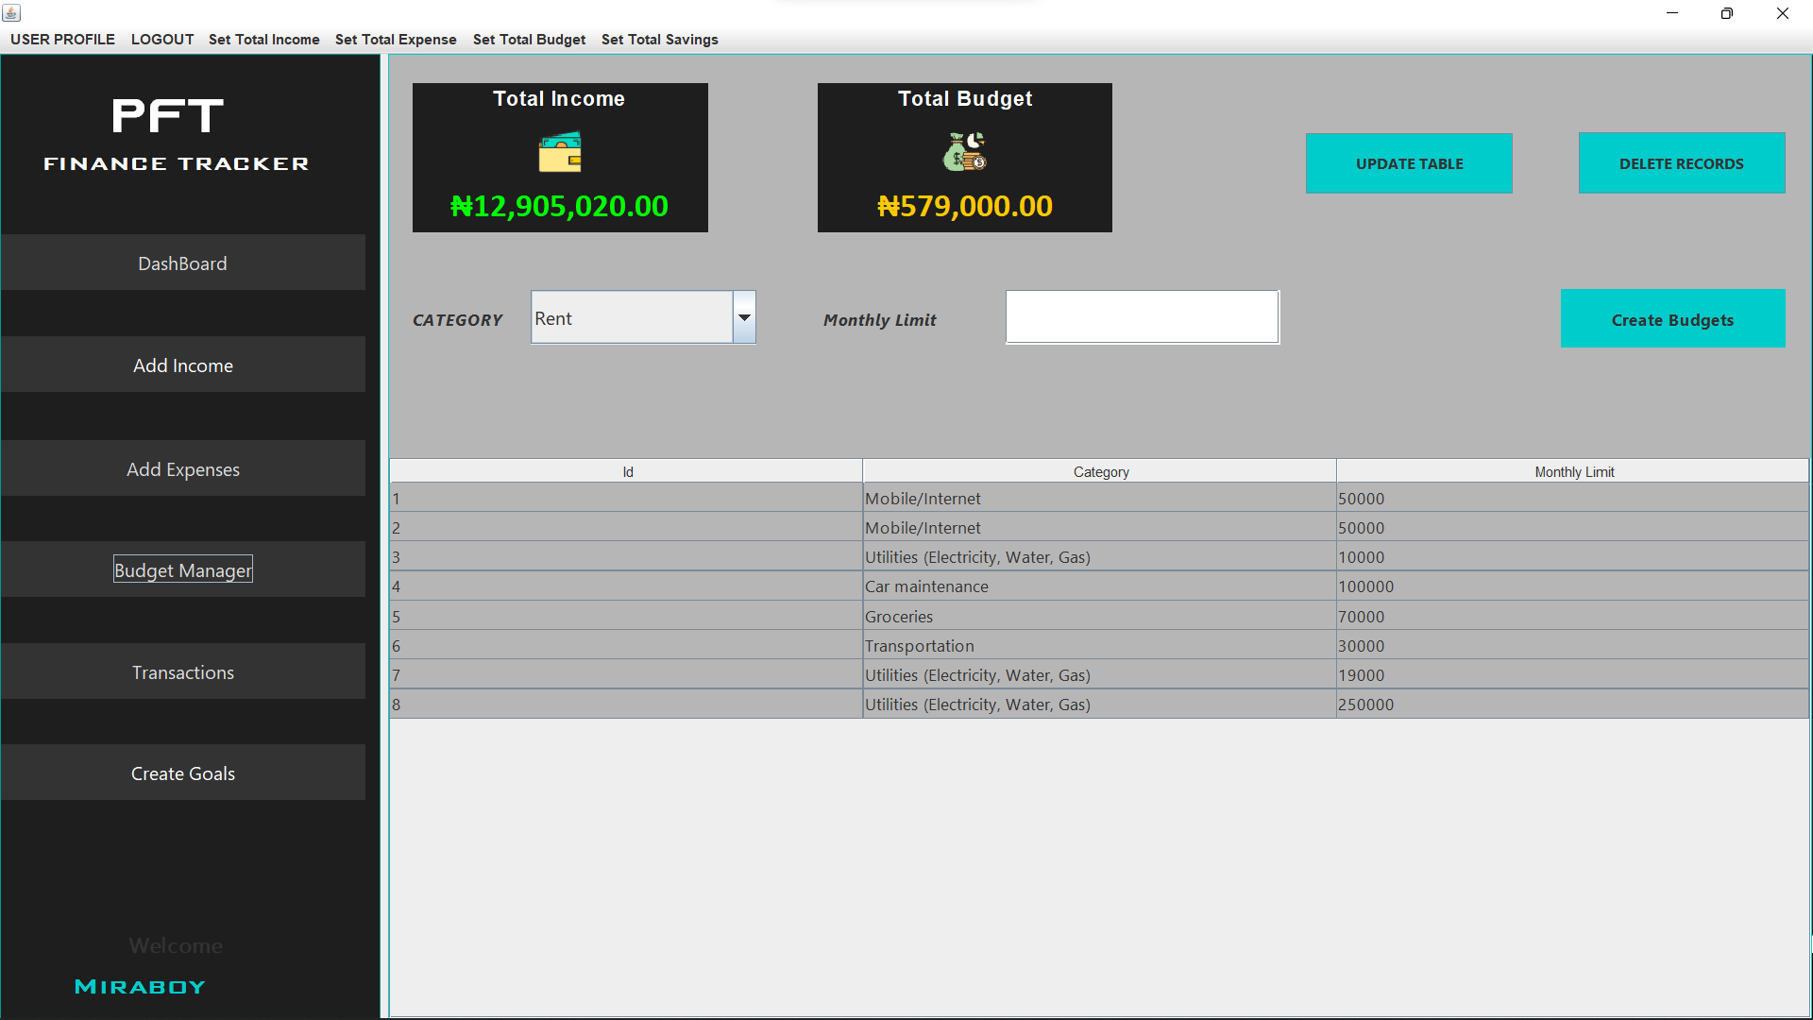

The **Budget** feature in the **Personal Finance Tracker** project allows users to set monthly spending limits for different expense categories. It helps users manage their finances more effectively by controlling overspending and encouraging disciplined money habits.

**Transaction:**

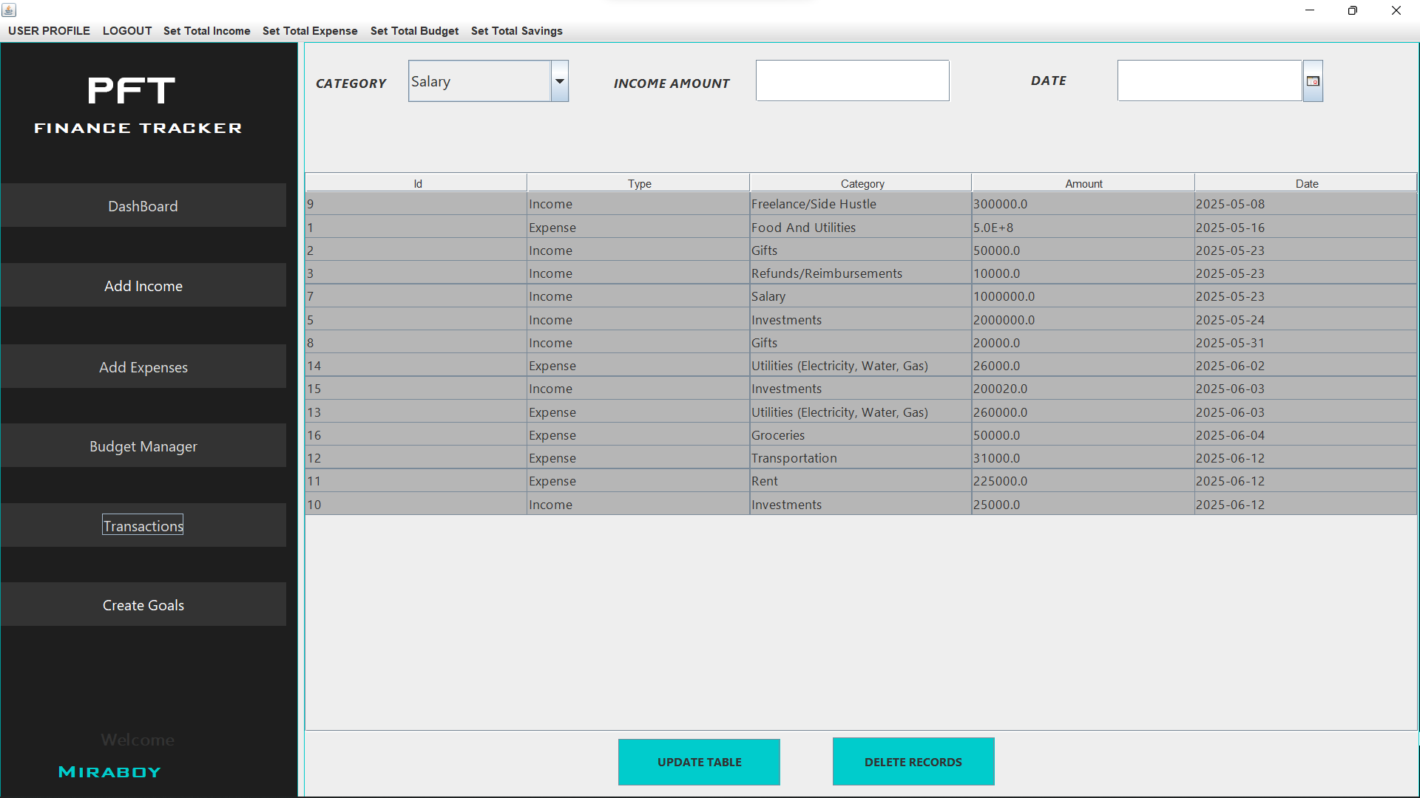

In the **Personal Finance Tracker** project, a **transaction** represents any financial event involving the flow of money—either as **income** (money received) or **expense** (money spent).

**Create Goal:**

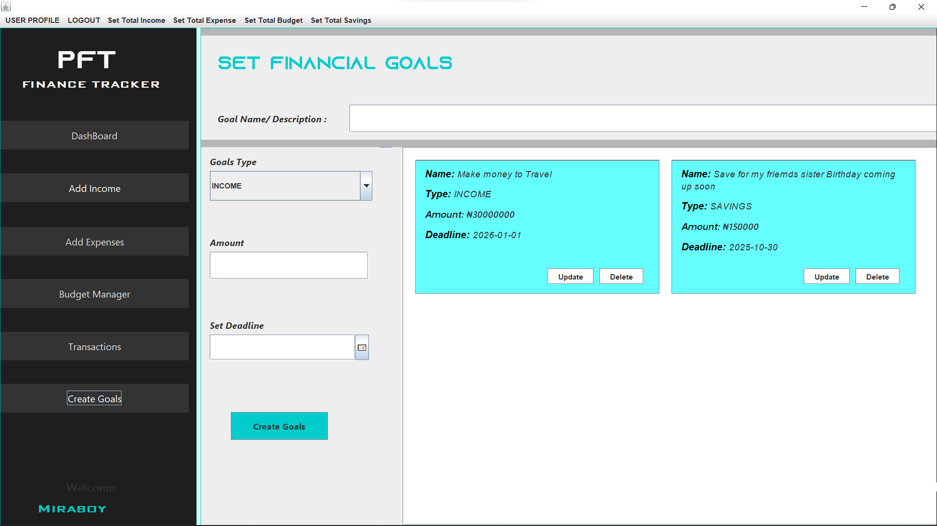

The **Create Goal** feature allows users to define and track personal financial objectives—such as saving for a purchase, paying off debt, or building an emergency fund.